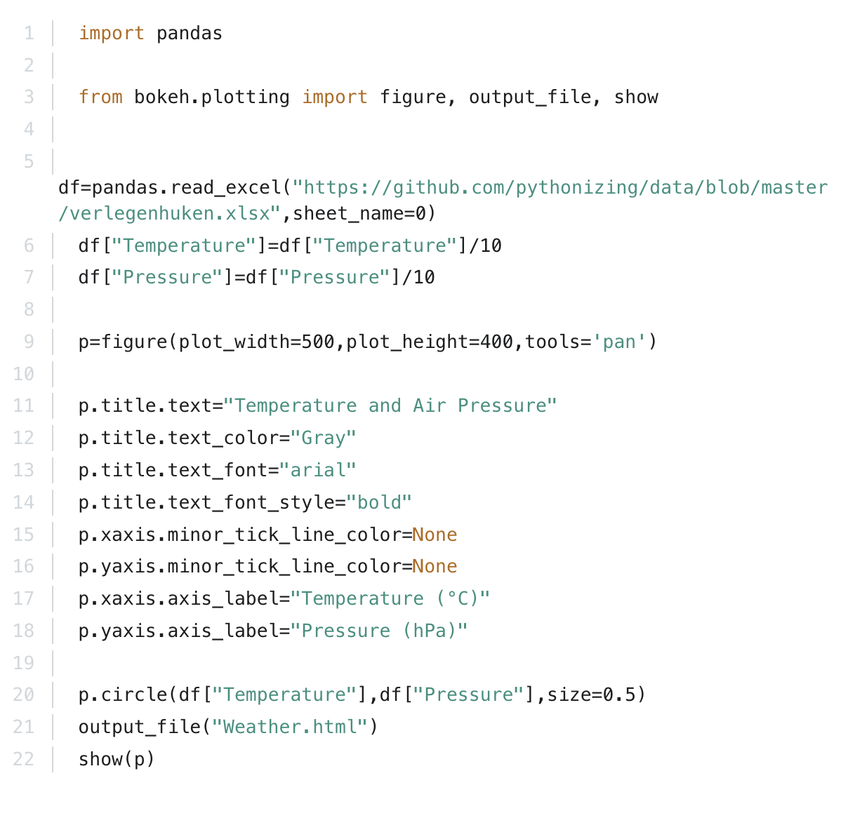
Solution: Plotting Weather Data

